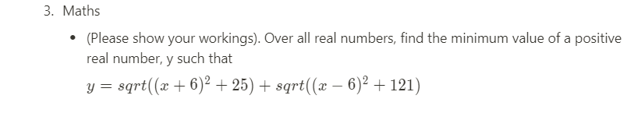 Y= 2+ 25 +

A = (x+6)^2+25 b = (x-6)2 +121

A = (x+6)(x+6)+25 b = (x-6)(x-6)+121

A = (x2+12x+36) +25 b = (x2-12x+36) +121

A +x2+12x+61 b = x2-12x=157

Y = x2+12x+61 + x2-12x+157

Factorizing A and B respectively.

Solving A and B using quadratic formular

A +x2+12x+61

A = 1, b = 12, c= 61

X = -6 J5

b = x2-12x=157

a = 1, b = -12, c = 15

$$\frac{-(-12)±\sqrt{{(-12)}^{2}-4(1)(157)}}{2}$$

$$\frac{12±\sqrt{144-628}}{2}$$

$$\frac{12±\sqrt{-484}}{2}$$

$$\frac{6±J22}{2}$$

X= 6 $±$ J11

X = -6 $±$ J5, X= 6 $±$ J11

Since we are considering real values of X, hence we test for when X=6

Y $\sqrt{{(6+6)}^{2}+25}$ + $\sqrt{{(6-6)}^{2}+121}$

$\sqrt{144+25}$ + $\sqrt{121}$

$\sqrt{169 +}$ $√121$

Y = 13 + 11

Y = 24

So, when X is real i.e.

X = 6, y = 24